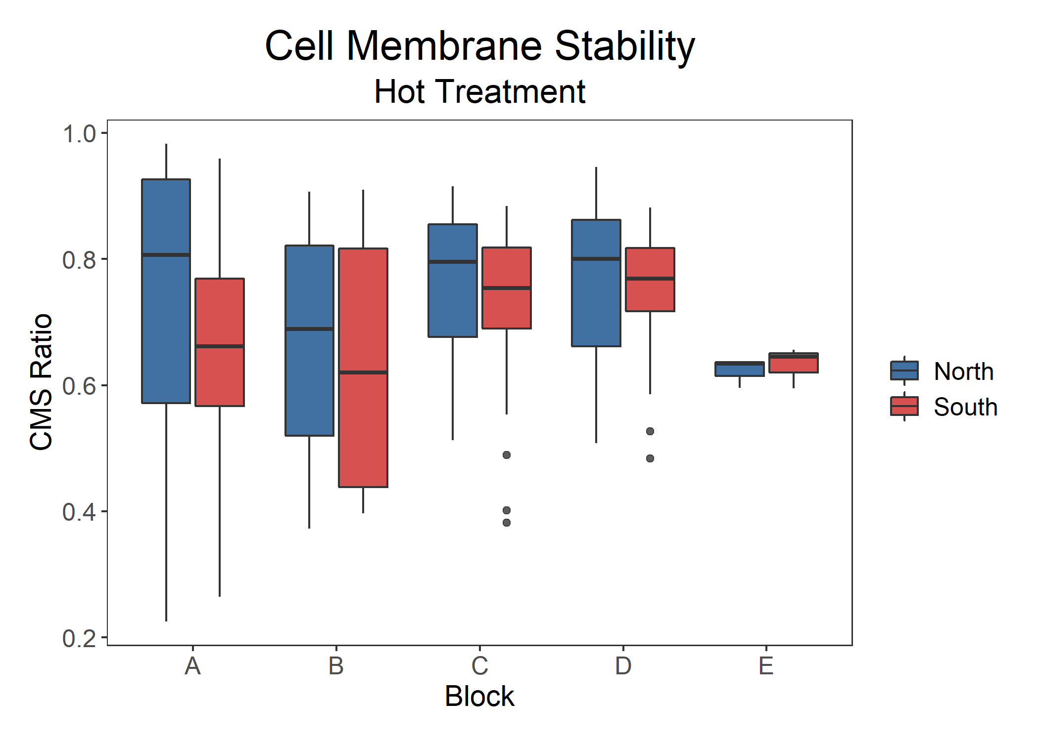

Figure: Cell membrane stability across temporally independent blocks and colored by region. ANOVA results show that there is a significant difference between blocks (p = 0.022, n = 202, df = 1).

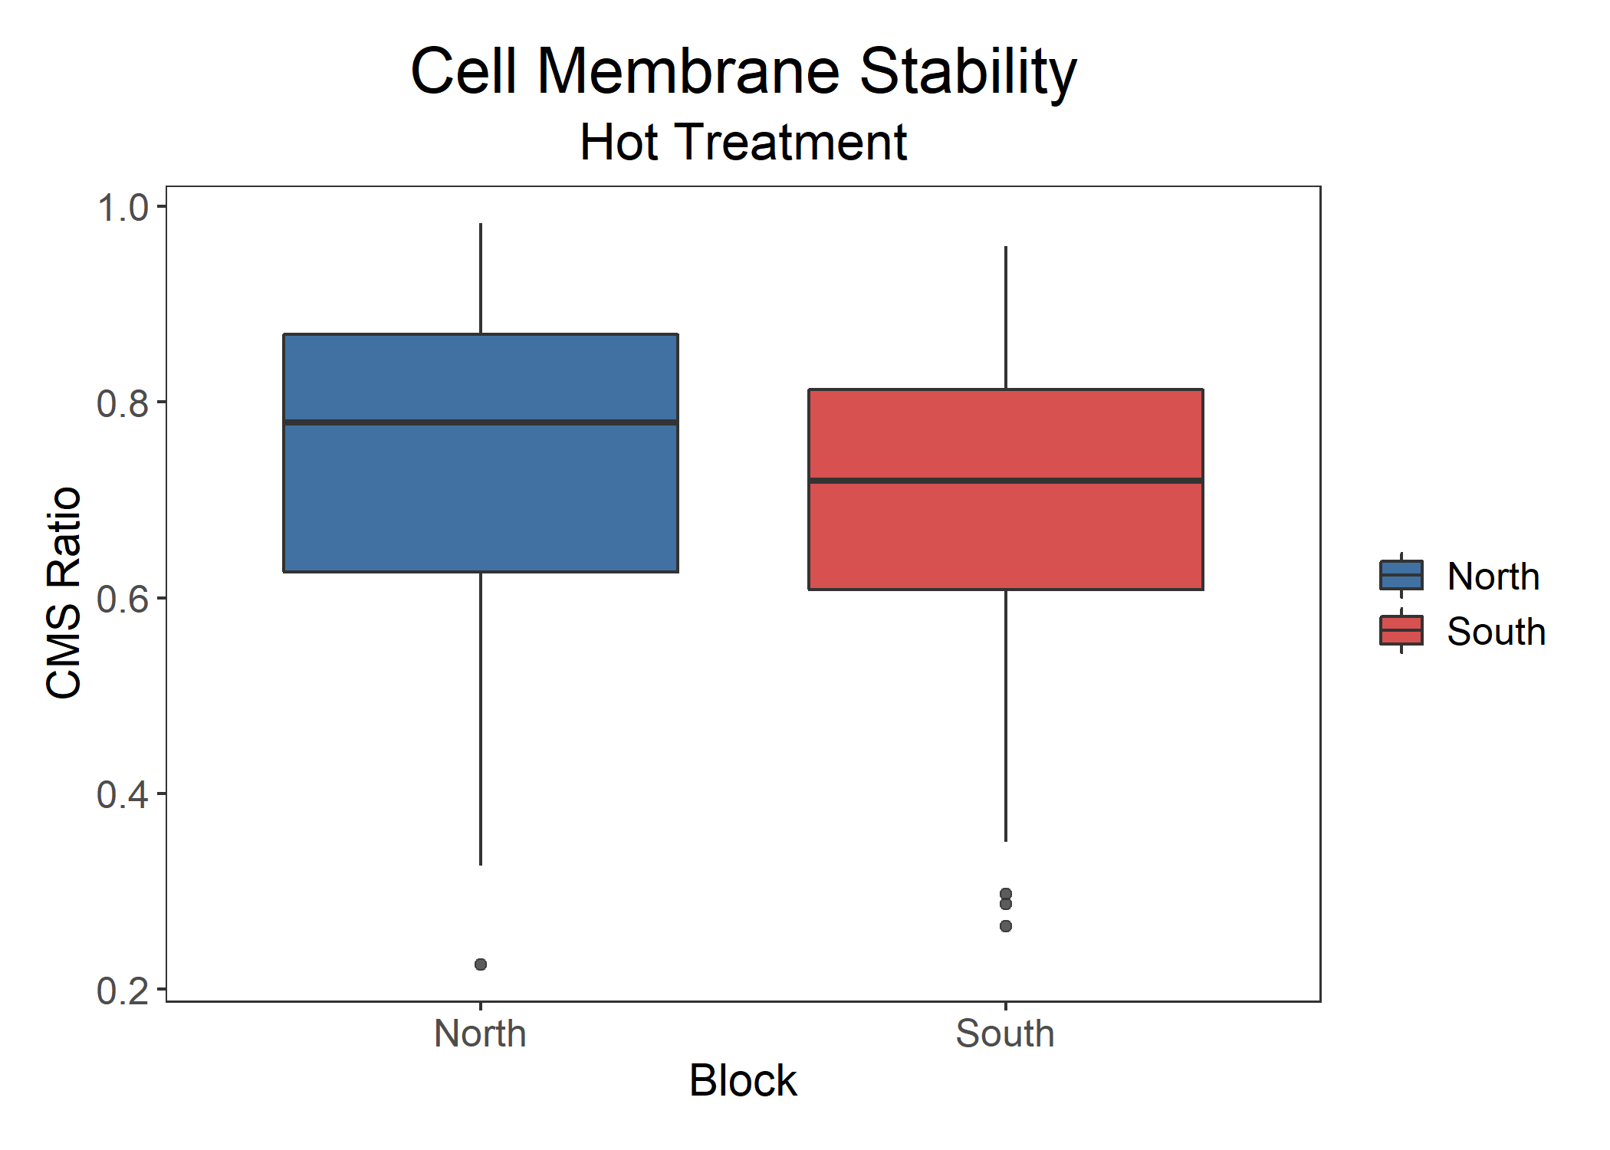

Figure: Cell membrane stability by region. ANOVA results show that there is no significant difference between regions of origin (p = 0.059).

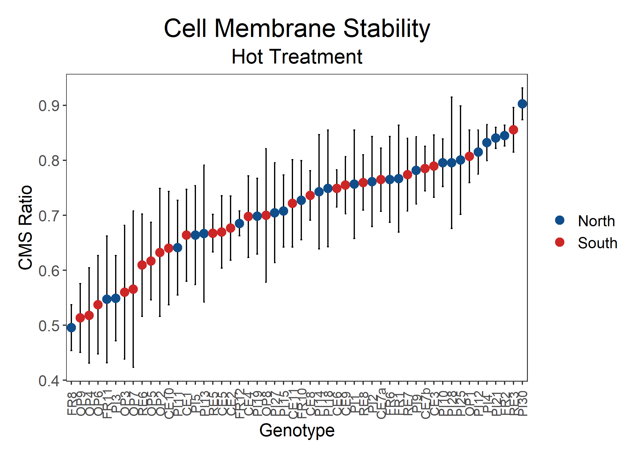

Figure: Cell membrane stability for all genotypes, colored by region. ANOVA results show that there is a significant difference between genotypes (df = 51, p = 0.032).

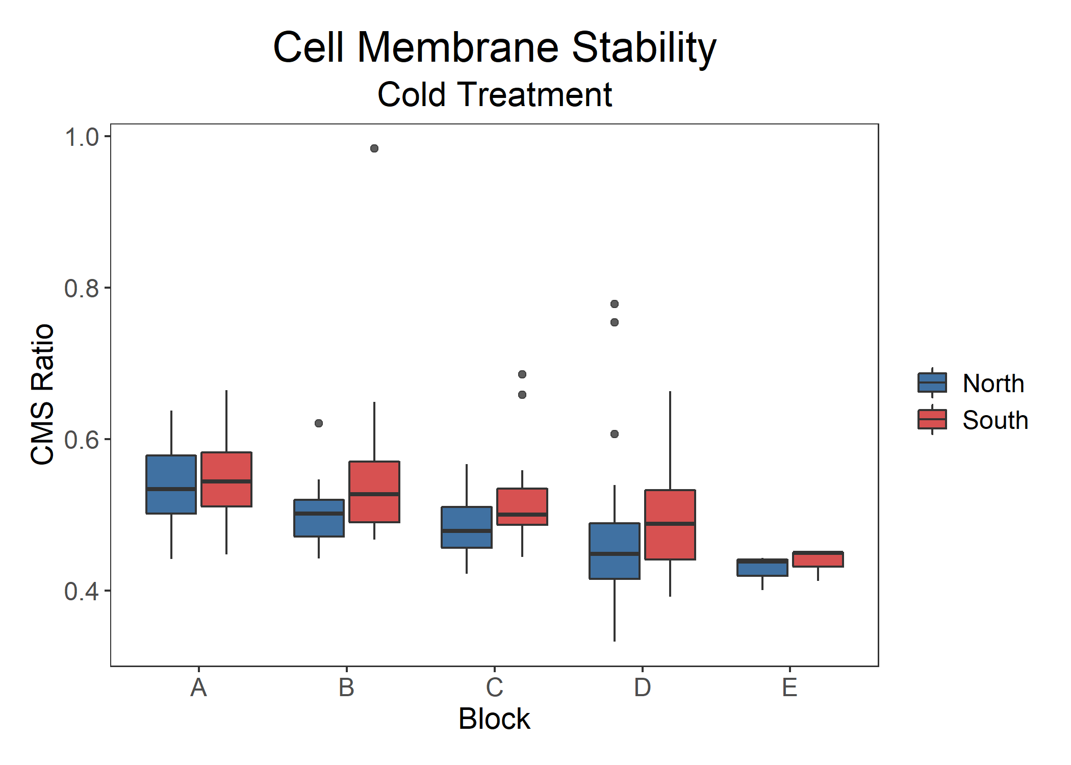

Figure: Cell membrane stability across temporally independent blocks and colored by region. ANOVA results show that there is a significant difference between the regions (p = 0.006, n = 202, df = 1) and the blocks (p = 5.7e-5).

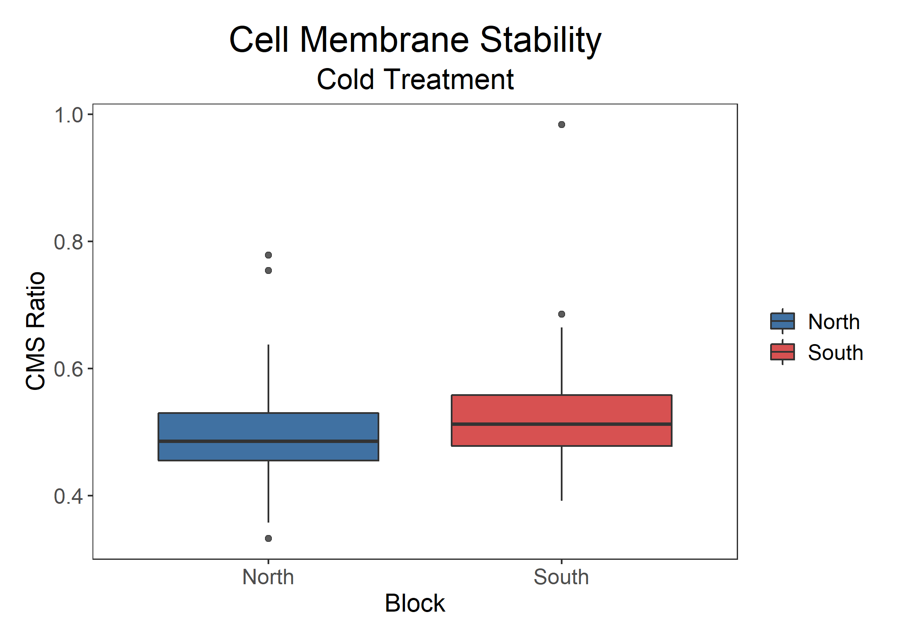

Figure: Cell membrane stability by region. ANOVA results show that there is a significant difference between the regions (p = 0.006, n = 202, df = 1).

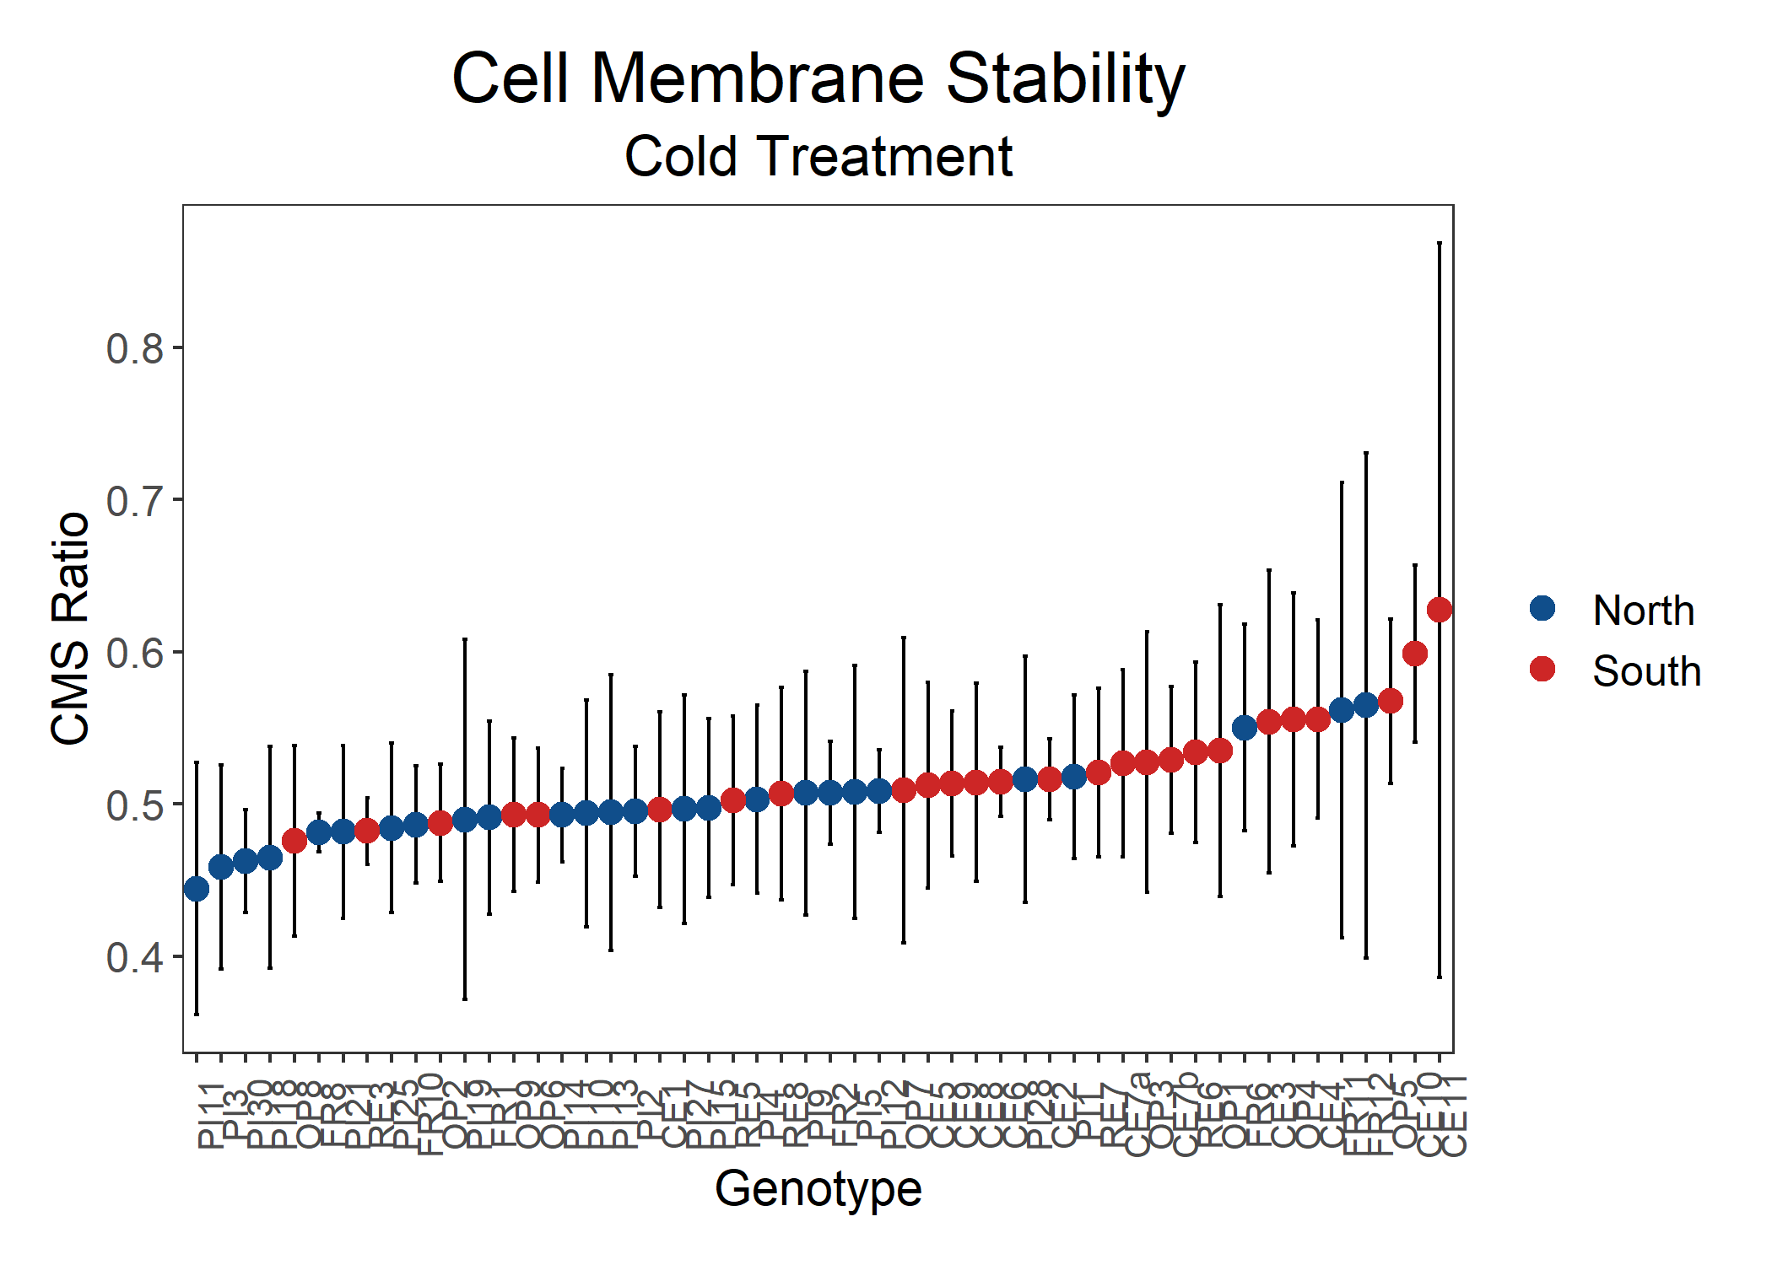

Figure: Cell membrane stability for all genotypes, colored by region. ANOVA results show that there is no significant difference between genotypes (df = 51, p = 0.86).

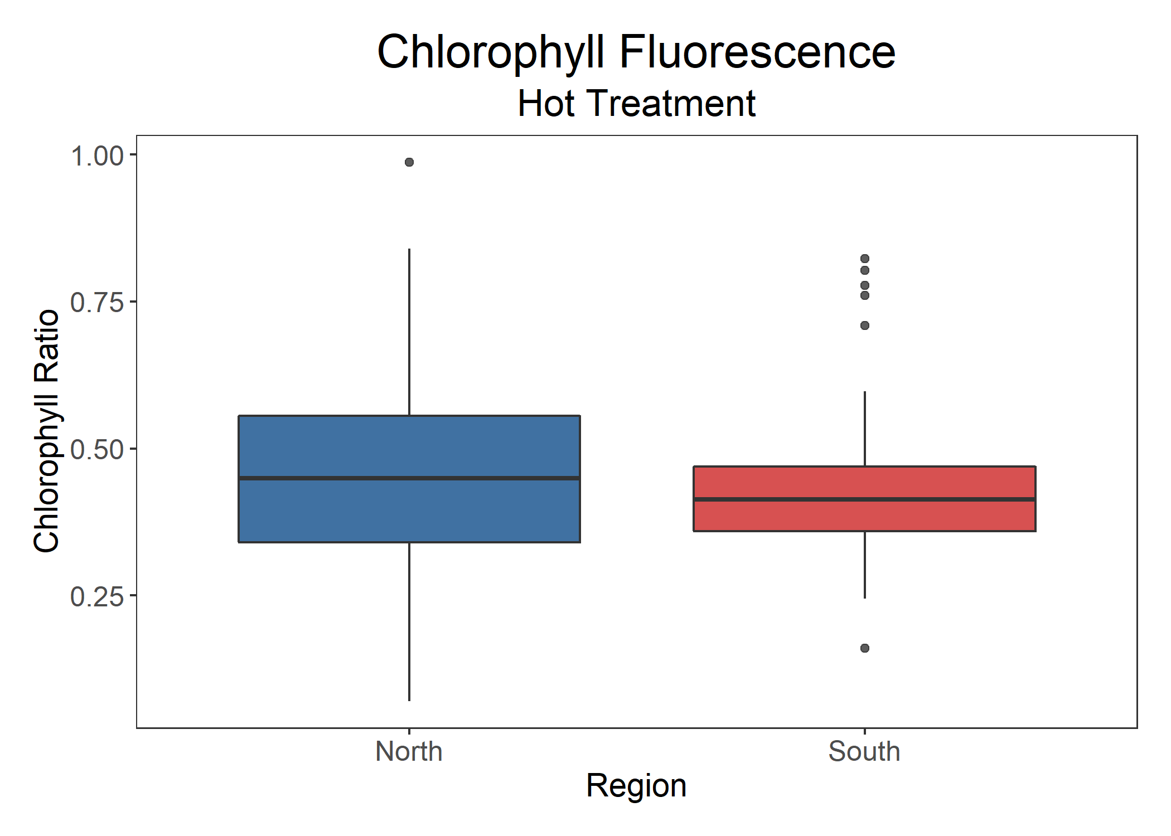

Figure: Chlorophyll content by region. ANOVA results show that there is a significant difference between the region (p = 0.043, n = 202, df = 1).

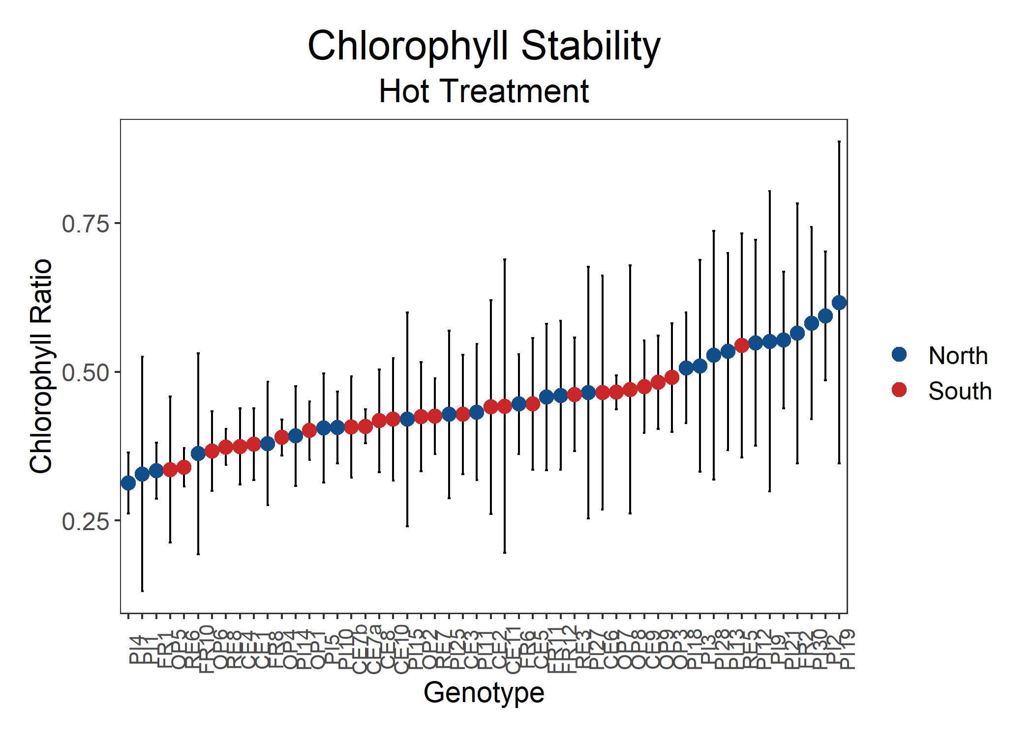

Figure: Chlorophyll stability for all genotypes, colored by region. ANOVA results show that there is no significant difference between genotypes (df = 51, p = 0.364).

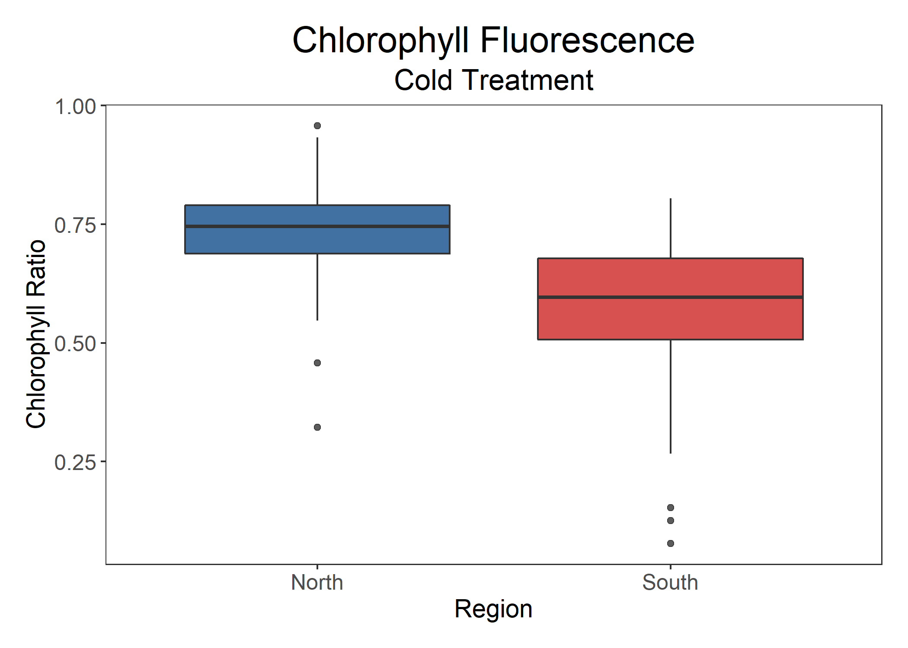

Figure: Chlorophyll content by region. ANOVA results show that there is a significant difference between the region (p = 1.6e-10, n = 202, df = 1).

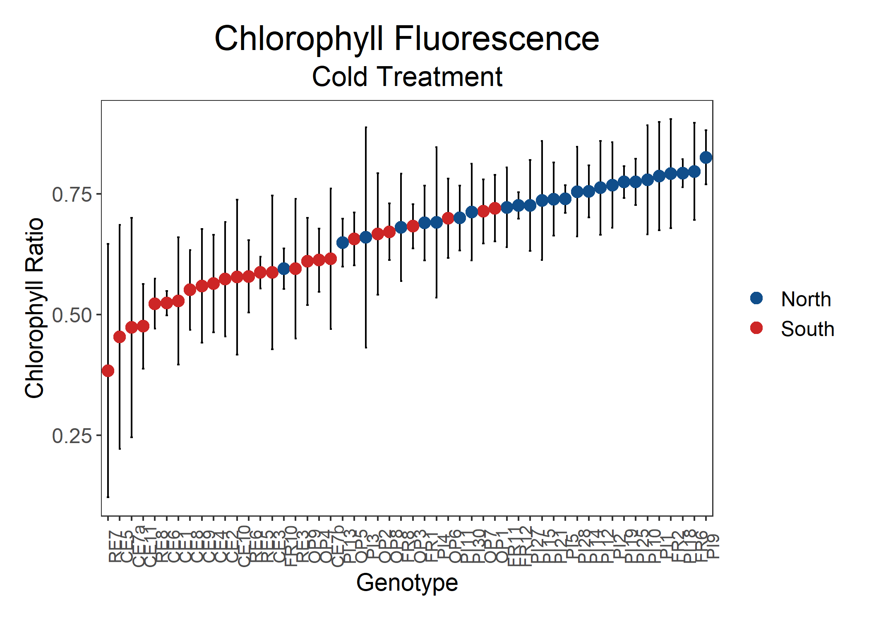

Figure: Chlorophyll stability for all genotypes, colored by region. ANOVA results show that there is a significant difference between genotypes (df = 51, p = 6.1e-9).

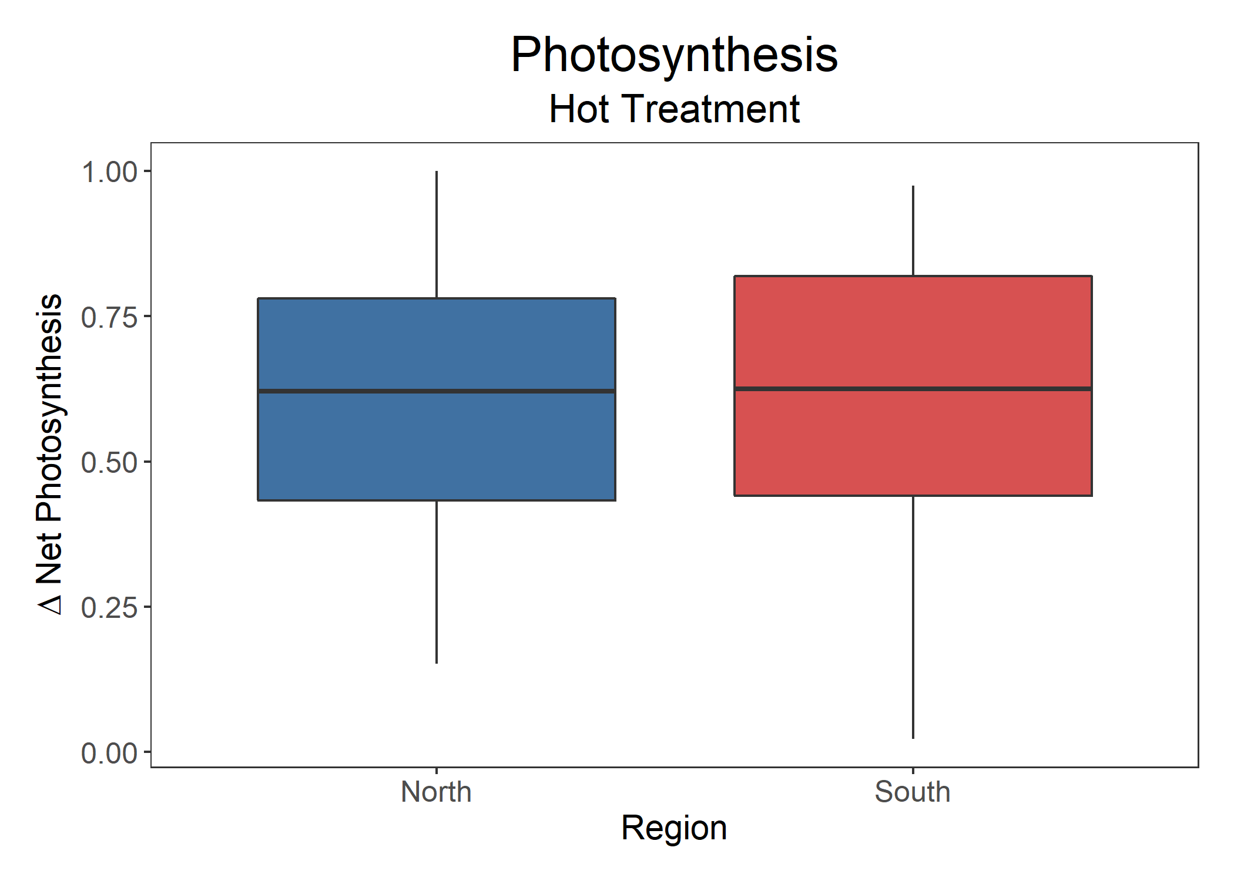

Figure: Photosynthesis by region. ANOVA results show that there is no significant difference between the regions (p = 0.87, n = 134, df = 1).

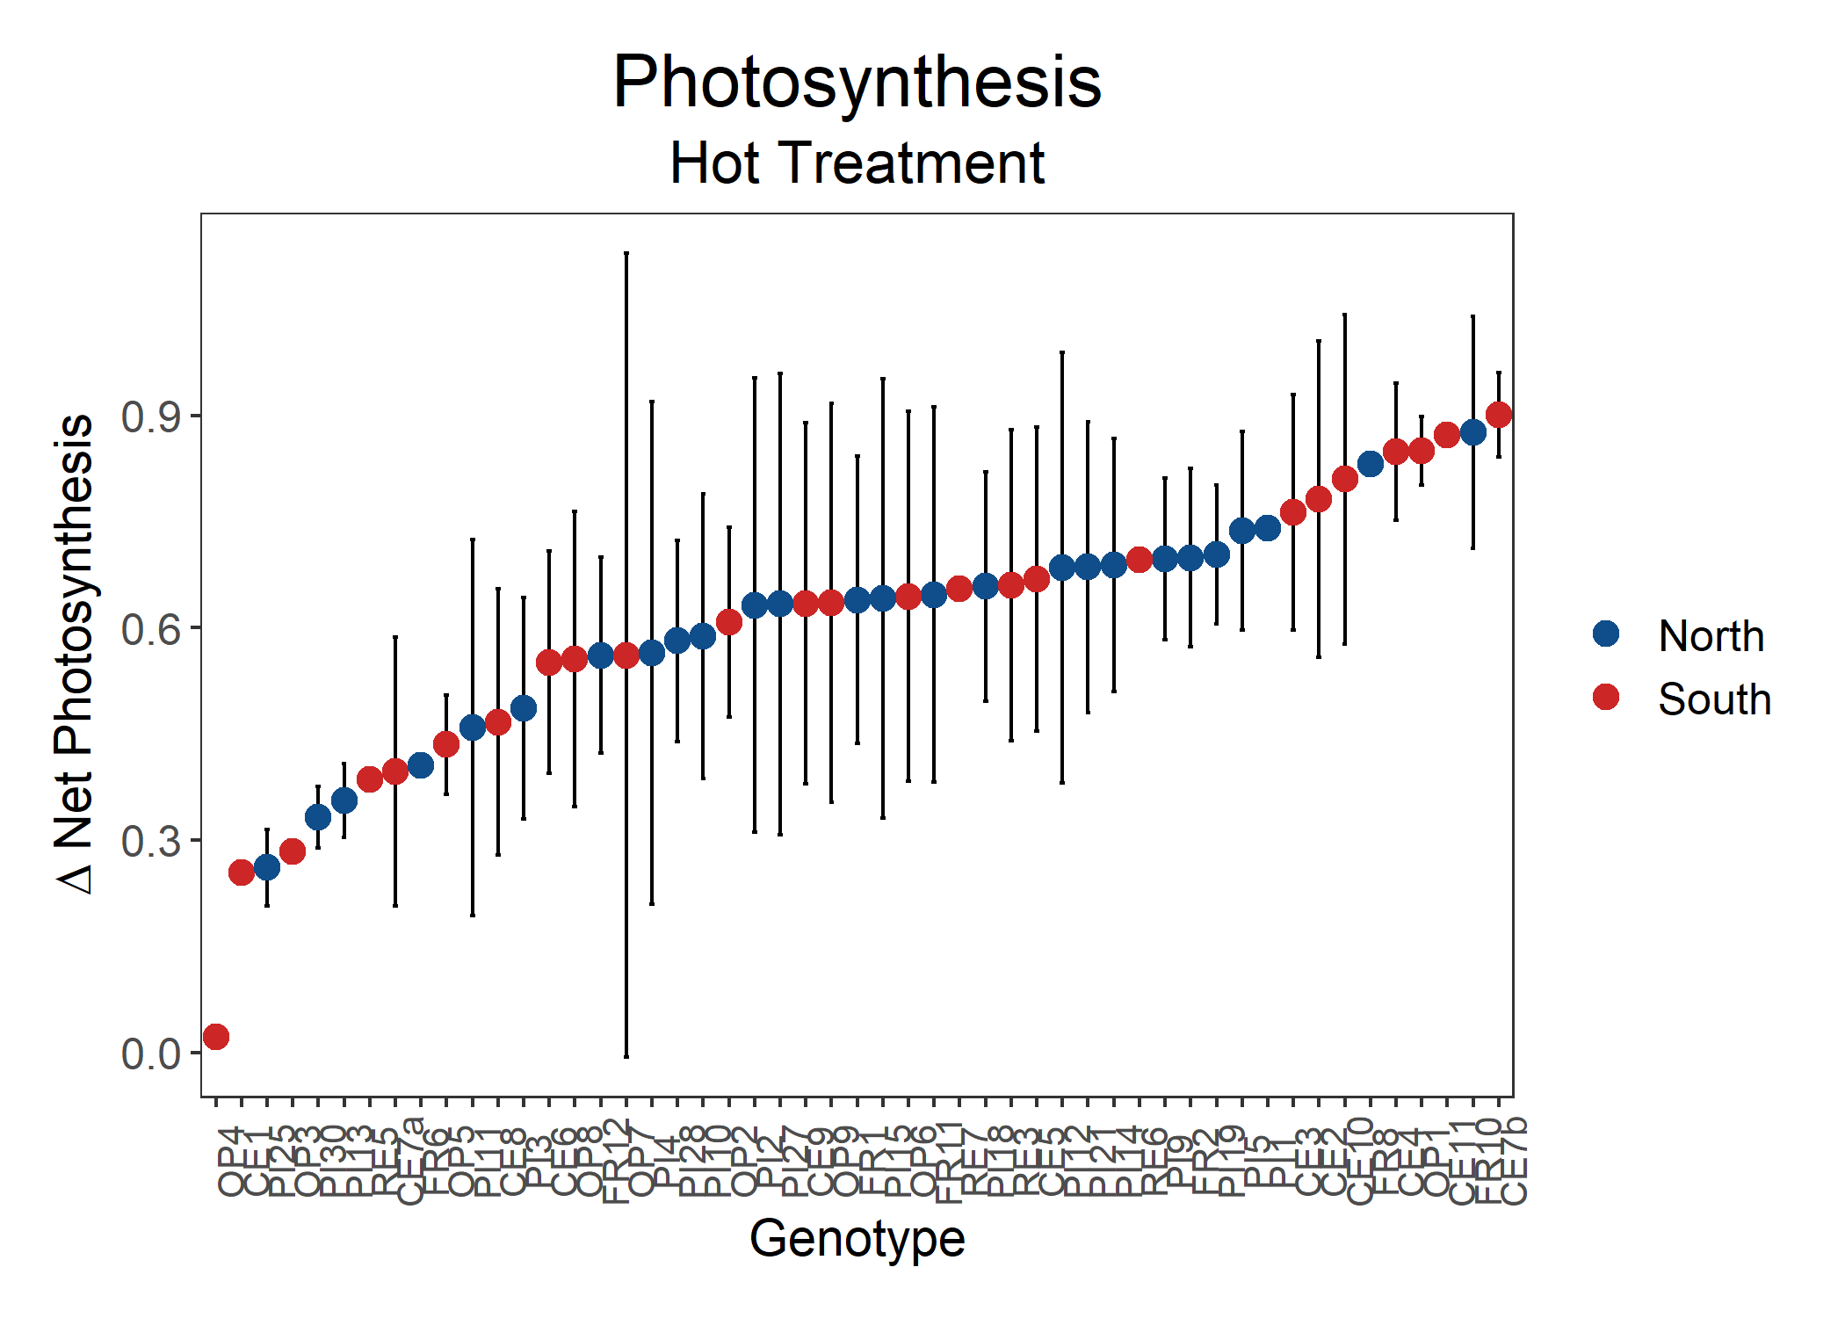

Figure: Net photosynthesis for all genotypes, colored by region. ANOVA results show that there is a significant difference between genotypes (df = 49, p = 0.097).

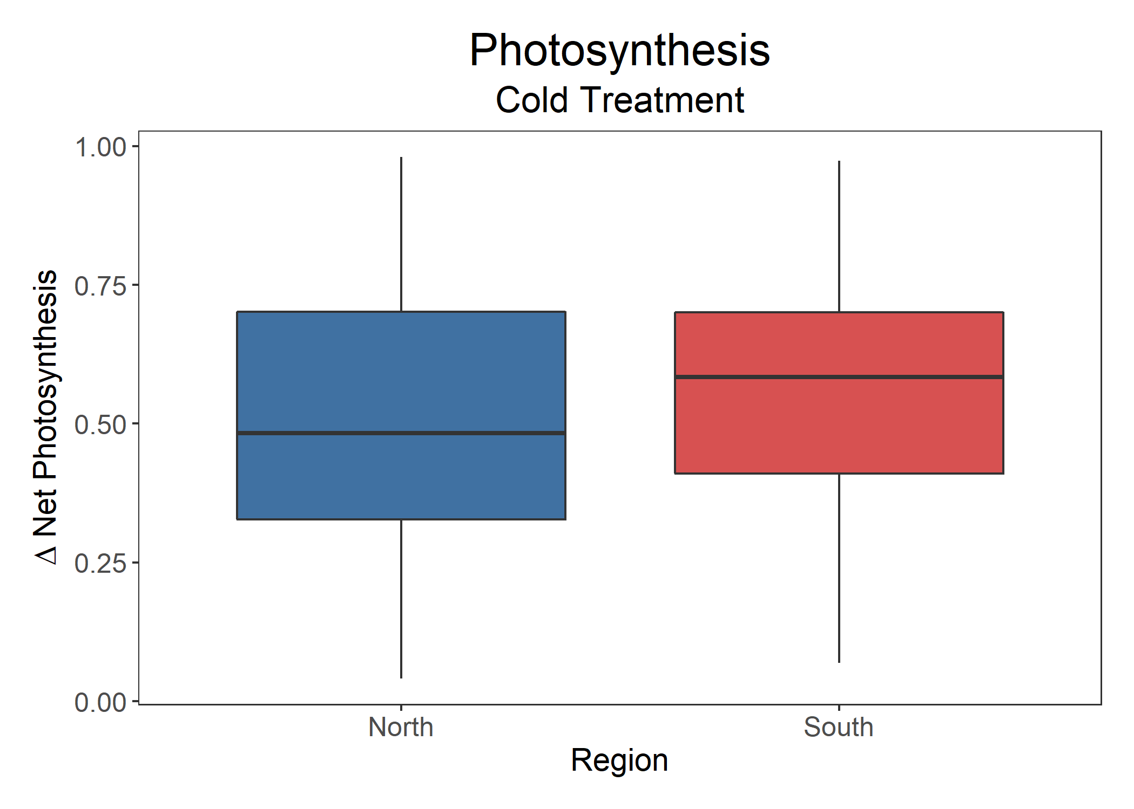

Figure: Net photosynthesis by region. ANOVA results show that there is no significant difference between the regions (p = 0.11, n = 147, df = 1).

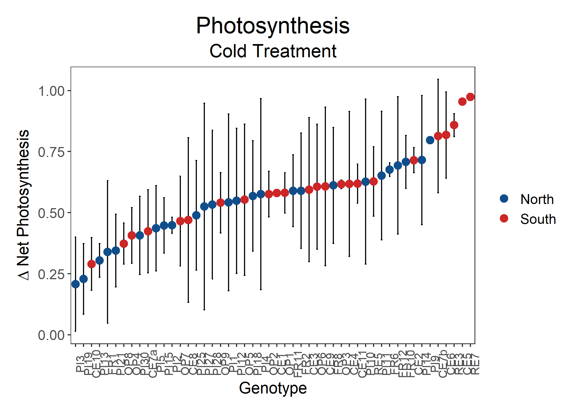

Figure: Net photosynthesis for all genotypes, colored by region. ANOVA results show that there is a significant difference between genotypes (df = 49, p = 0.089).

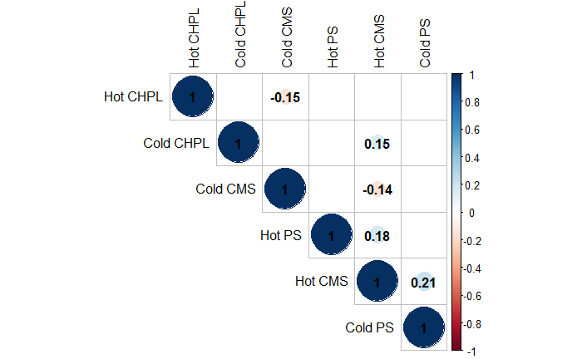

Figure: Correlation matrix of sporophytic variables with significant Pearson’s correlations.

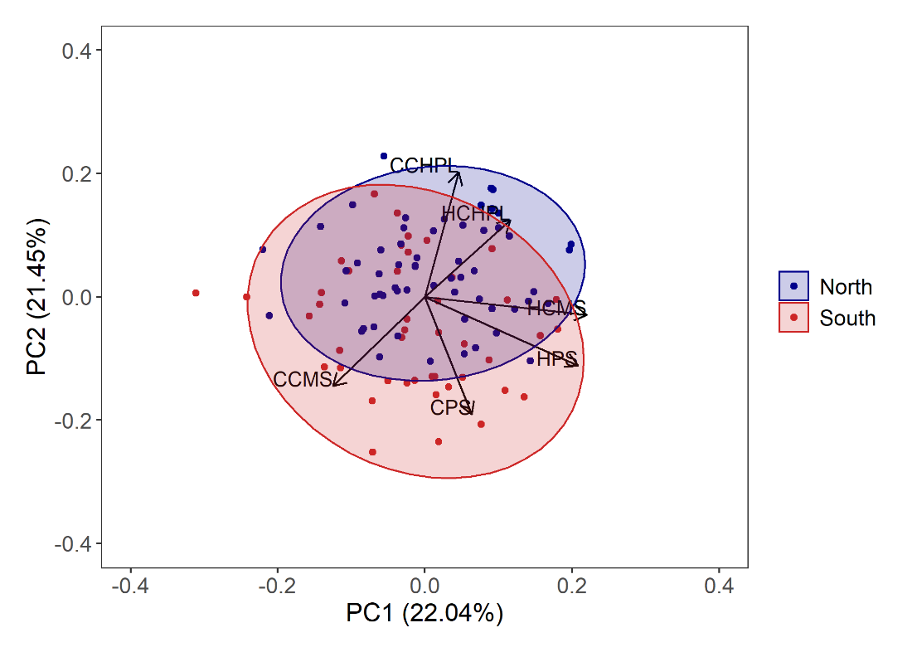

Figure: PC1 and PC2 from principal component analysis for all sporophytic variables with 95% confidence ellipse. PC1 explains 22.04% of the variance and PC2 explains 21.45% of the variance.

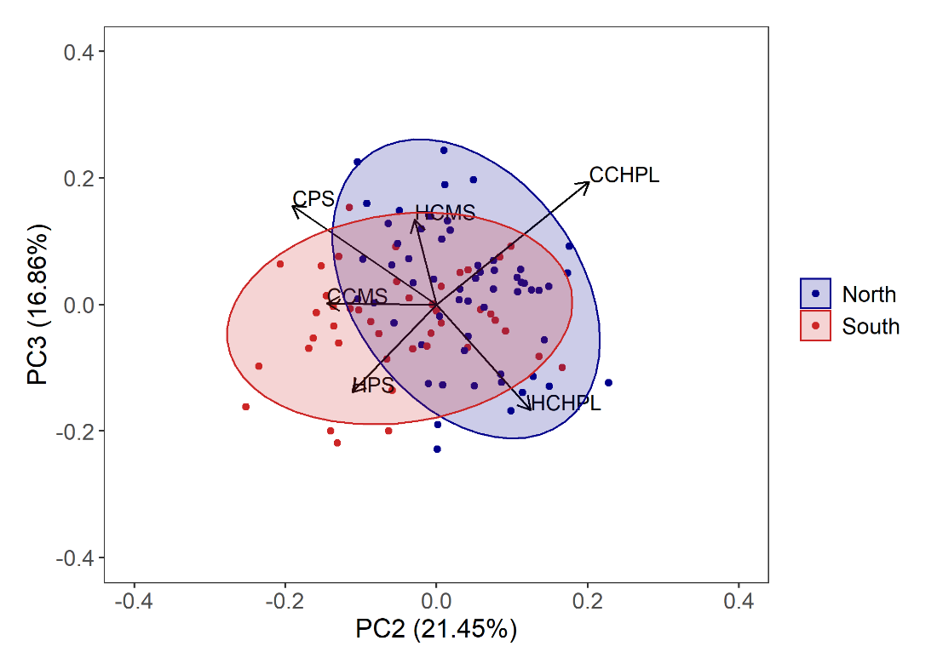

Figure: PC2 and PC3 from principal component analysis for all sporophytic variables with 95% confidence ellipse. PC2 explains 21.45% of the variance and PC3 explains 16.86% of the variance.

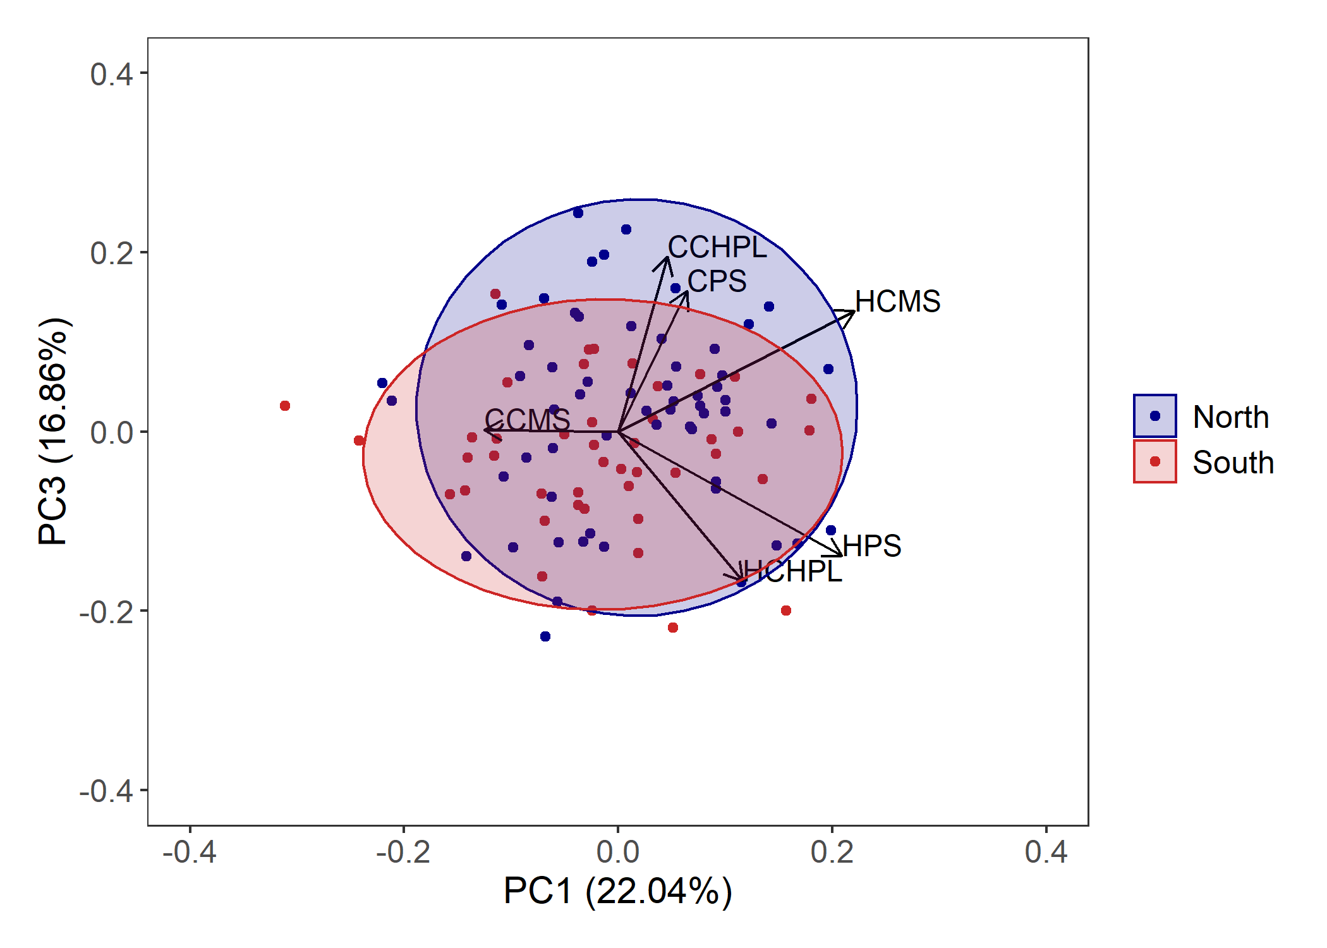

Figure: PC1 and PC3 from principal component analysis for all sporophytic variables with 95% confidence ellipse. PC1 explains 22.04% of the variance and PC3 explains 16.86% of the variance.

***Gametophytic Variables***

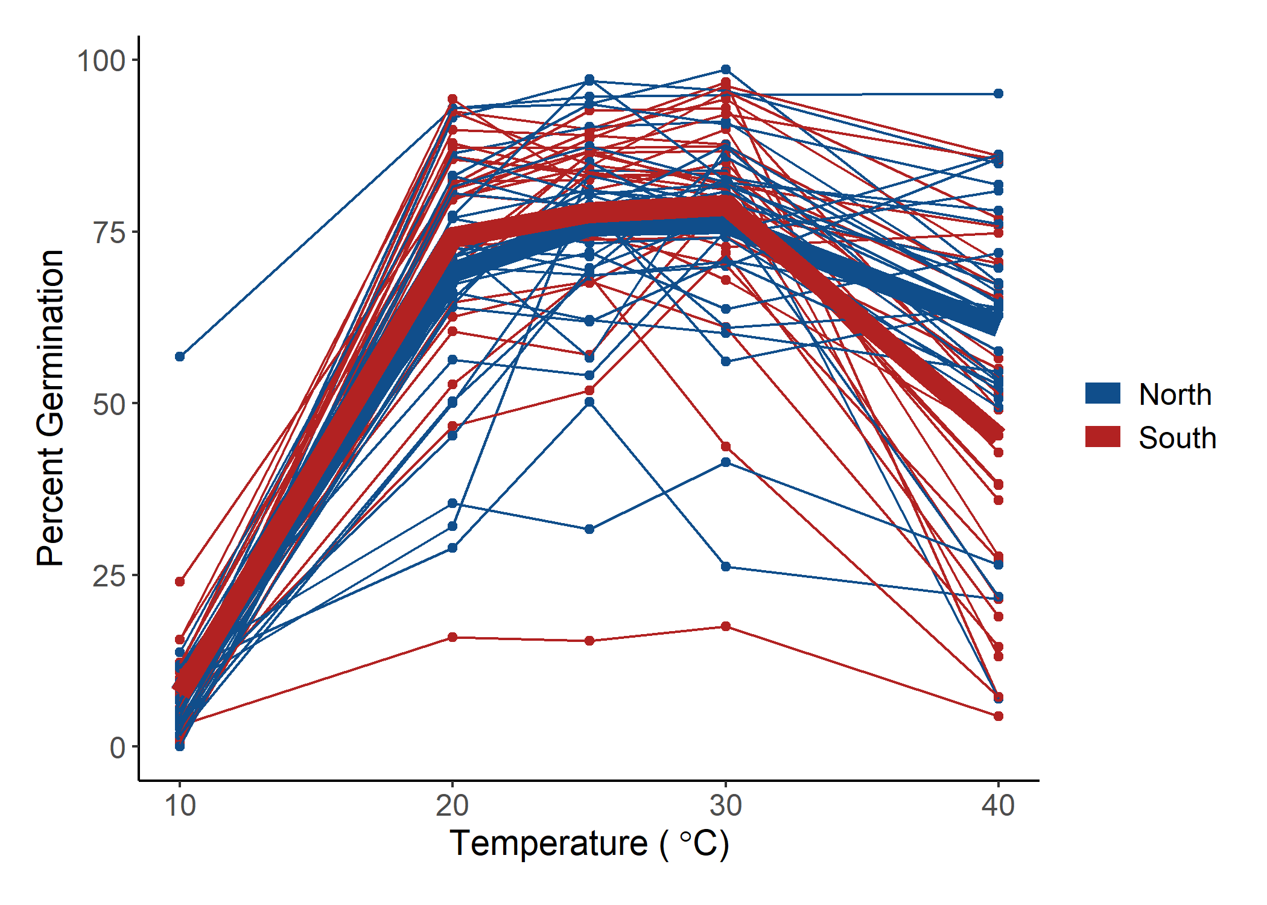

Figure: Percent germination for *Solanum carolinense* pollen grains from the north (blue) and south (red) across a temperature gradient. Thick lines indicate the mean value for the region at each temperature.

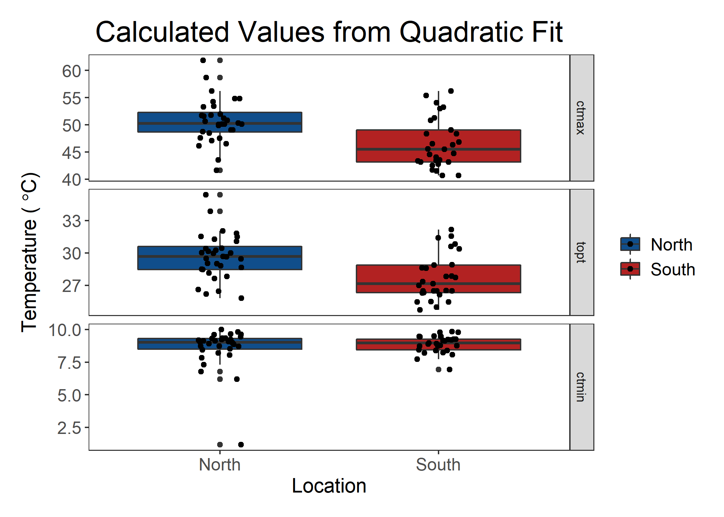

Figure: Estimates for the maximum (Tmax), optimal (Topt), and minimum (Tmin) germination temperatures attained using bilinear fits of the germination data for each individual. There is a significant difference between north and south for Tmax (Mann-Whitney, p = 0.003), but not for Topt and Tmin.

*Pollen Tube Growth Rate*

Figure: Percent tube growth rate for *Solanum carolinense* pollen grains from the north (blue) and south (red) across a temperature gradient. Thick lines indicate the mean value for the region at each temperature.

